

Department | FED
Subject | DSA-2
Academic Year | I-III Semester(2025-26)
Faculty Name | Gopi Krishna
Student Name | V Sri Bhargavi
Roll Number | 2520040048
Branch | ECE
Course Outcome | 1

Case Study Topic : Smart City Road Network Optimization using Kruskal’s MST

Work Done Summary:

In this case study, we created a weighted graph representing possible road connections between city zones.
Using Kruskal’s algorithm, we constructed a Minimum Spanning Tree to minimize total construction cost.
We used Union-Find data structure for cycle detection.

Implementation Details:
- Represented the road network as an edge list (source, destination, distance).
- Sorted all edges based on their weights.
- Applied Disjoint Set Union (Union-Find) for cycle detection.
- Added the shortest non-cyclic edges to form the MST.
- Computed the total minimum cost of the constructed network.
- Validated MST properties: minimal cost + full connectivity.
Result: Screenshots :
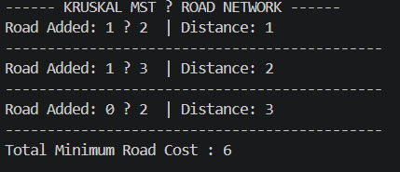
Kruskal’s Algorithm efficiently generated a Minimum Spanning Tree (MST) for the city’s road network.
The roads added to the MST were:
1–2 (1), 1–3 (2), 0–2 (3)
Total Minimum Cost: 6
Time Complexity:
• Sorting Edges: O(E log E)
• MST Construction: O(E log V)
GitHub Link: https://github.com/sribhargavivaddavalli-svg/DSA_CASESTUDIES

